20. John Maxwell Mouna.
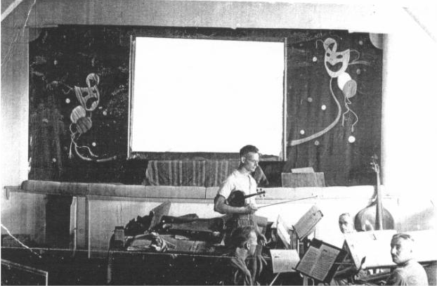
John Maxwell (‘Max’) Mouna was born March quarter 1920 in Liverpool, the son of John Louis Mouna a plumber, and Florence Mouna (nee Dickinson). They subsequently moved to Maesmawr House, Llangollen, John Maxwell Mouna was Lance Serjeant, No. 905333, 106 (The Lancashire Hussars) Light Anti Aircraft Regiment, Royal Artillery. He became a POW June 4, 1941, and was later in Stalag 18A, Wolfsberg, which was a clearing camp for scores of working camps in Austria. (Many of the British prisoners at Wolfsberg were captured during the Crete Campaign.) Whilst he was at Wolsfberg he participated in performances at the camp theatre, where he played keyboard. He died of Lymphosarcoma in hospital in Austria, 12th September 1944, and was buried in grave 6. B. 15., Klagenfurt Carinthia War Cemetery, Austria, note that those who died at work camps were buried locally initially, but later transferred to Klagenfurt.
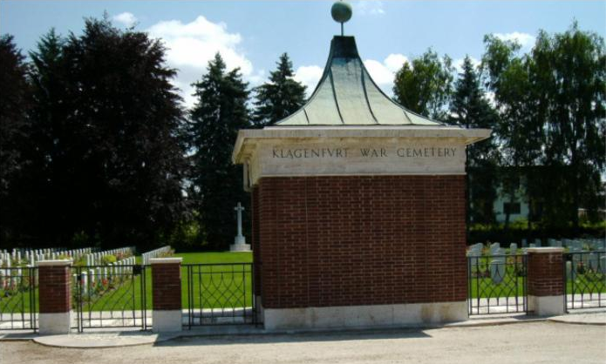
Name: Mouna, John Maxwell, Rank: Lance Serjeant, Service No: 905333
Regiment/Service: Royal Artillery, Unit Text: 106 (The Lancashire Hussars) Lt A.A. Regt
Date Of Death: 12/09/1944
Grave/Memorial Reference: 6. B. 15., Cemetery: Klagenfurt War Cemetery, Austria .
June 1918 John L Mouna m Florence Dickinson, Liverpool
b march 1920, Liverpool
6th October 1944
Death – News has been received from the War Office by his parents (Mr. and Mrs. J.L. Mouna, Maesmor House), of the death of their beloved son, John Maxwell Mouna (Max), aged 24 years, who died in hospital in Austria, where he had been a prisoner of war since June 4, 1941.

