23. Eric Jones Roberts.
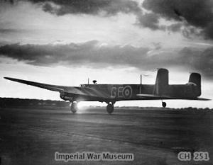
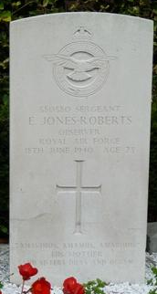
Eric Jones Roberts was born September quarter 1916 in Llangollen, son of Charles Jones Roberts and Elizabeth Ann Jones-Roberts (nee Roberts), with his twin sisters being born in the June quarter of 1919. His father Charles Jones-Roberts, who had worked on his father’s farm (Bache Canol) and later occupied Ty Brython, died 21st May 1928 aged 48. Eric joined the R.A.F. (service number 580580), and became a Sergeant (Obs), a Navigator/Bomb Aimer, with 58 Squadron, which was part of Bomber Command from February 1940, based at Linton-on-Ouse. 58 Squadron were equipped with Armstrong Whitworth Whitley Mk.V Aircraft, a two engined bomber with a crew of 5. It had a machine gun in the nose, and a gun turret at the rear. The crew of Whitley Mk. V, Serial Number N1463, GE-L was pilot F/S G.J.Ford, second pilot Sgt H.P.Maguire navigator Sgt E.Jones-Roberts gunner Sgt A.E.Furze and gunner Sgt F.S.Staley. On 17th June 1940 10 aircraft from 58 Squadron participated in a attack an oil plant at Gelsenkirchen. They were airborne 21.40 That night there were mechanical problems with the aircraft, the bomb release mechanism had stuck and a few bombs remained in the bomb bay after the drop. Eric Jones-Roberts had been wounded, he had been hit by nose gun, and despite the assistance of the second pilot had lost consciousness, so they were without a navigator. The pilot tried to navigate on the basis of previous experience, but strayed off course and passed over Soesterberg. The Whitley was hit by flak and the left engine caught fire, so the pilot gave orders to bail out. The gunners and second pilot were able to bail out, despite the aircraft being a blaze of fire. The pilot saw the aircraft was headed towards a row of houses, so he turned the plane away to starboard to avoid them – avoiding a farm house where sixty Dutch troops were quartered. The plane crossed the dyke and travelled 100 m into the flood plane on land identified at the Schalkwijkse Heul, alongside the Beusichemsedijk on S bank of the river Lek at Beusichem (Gederland). The front of the plane was crushed, and the tail broke off, the pilot and navigator were killed. Despite the fire there were still unexploded bomb on board, which were detonated a few days later. The three other crew members were taken as POW’s. After the war the bodies of the pilot and navigator were excavated, and buried at Culemborg General Cemetery, NL. Sergeant Jones-Roberts’ mother and sisters Dilys and Olwen inscribed on his grave “A mavimus, animus, amabimus” “we loved him, we still love him and we will always keep him.”
N1463 GE-L June 1940

1911 Bache Canol Llangollen; County: Merionethshire
John Roberts Head M 60(1851) Farmer Montgomeryshire Llanrfyllin
Mary Roberts Wife M 59(1852) Married 39 Y 11c 1d Shropshire Llanblodwer
Charles Roberts Son S 30(1881) Farmer Son Working On Farm Denbigh Llangollen
Mary Ellen Roberts Dau S 28(1883) Farmer Daughter Cook Denbigh Llangollen
Emily Roberts Dau S 25(1886 Farmer Daughter Dairy Work Denbigh Llangollen
Blodwen Roberts Dau S 22(1889) Farmer Daughter Denbigh Llangollen
Henry Selwyn Roberts Gson S 13(1898) School Denbigh Llangollen
David Williams Serv S 24(1887) Waggoner Denbigh Llangollen
Edward Edwards Serv S 45(1866) Labourer Shropshire Oswestry
Sergeant (Obs) Eric Jones-Roberts, RAF 580580, 58 Squadron, age 23 18/06/1940, Culemborg General Cemetery, NL

Whitley N1463 Information
Type Whitley
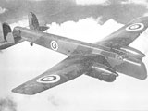
Serial Number N1463
Squadron 58
X1D GE-L
Operation Gelsenkirchen
Date 1 17th June 1940
Date 2 18th June 1940

Further Information
"Serial Range N1459 - N1508. 50 Whitley Mk.V. Delivered by Armstrong Whitworth Aircraft between 7Dec39 and 3Mar40. Contract No.75147/38. Airborne 2140 17Jun40 from Linton-on-Ouse. Crashed, due to engine failure, at midnight, on land identified at the Schalkwijkse Heul, alongside the Beusichemsedijk on the S bank of the River Lek at Beusichem (Gelderland), Holland. F/S G.J.Ford KIA Sgt H.P.Maguire PoW Sgt E.Jones-Roberts KIA Sgt A.E.Furze PoW Sgt F.S.Staley PoW Sgt A.E.Furze was interned in Camps L1/L6/357, PoW No.56 with Sgt F.S.Staley, PoW No.54. Sgt H.P.Maguire (also initialled H.P.F.) in Camps L1/L6, PoW No.61. Sgt E.Jones-Roberts (KIA) is also recorded as Sgt E.Jones-Robertson (PoW). Sgt F.S.Staley is recorded also as Sgt F.S.Stanley. "
17-18/06/1940: Gelsenkirchen, D
10 Sqdn. (3 aircraft), 51 Sqdn. (7 a/c), 58 Sqdn. (10 a/c) and 77 Sqdn. (9 a/c) attack an oil plant at Gelsenkirchen.
Sgt A.E.Furze was interned in Camps L1/L6/357, PoW No.56 with Sgt F.S.Staley, PoW No.54. Sgt H.P.Maguire (also initialled H.P.F.) in Camps L1/L6, PoW No.61. Sgt F.S.Staley is recorded also as Sgt F.S.Stanley.
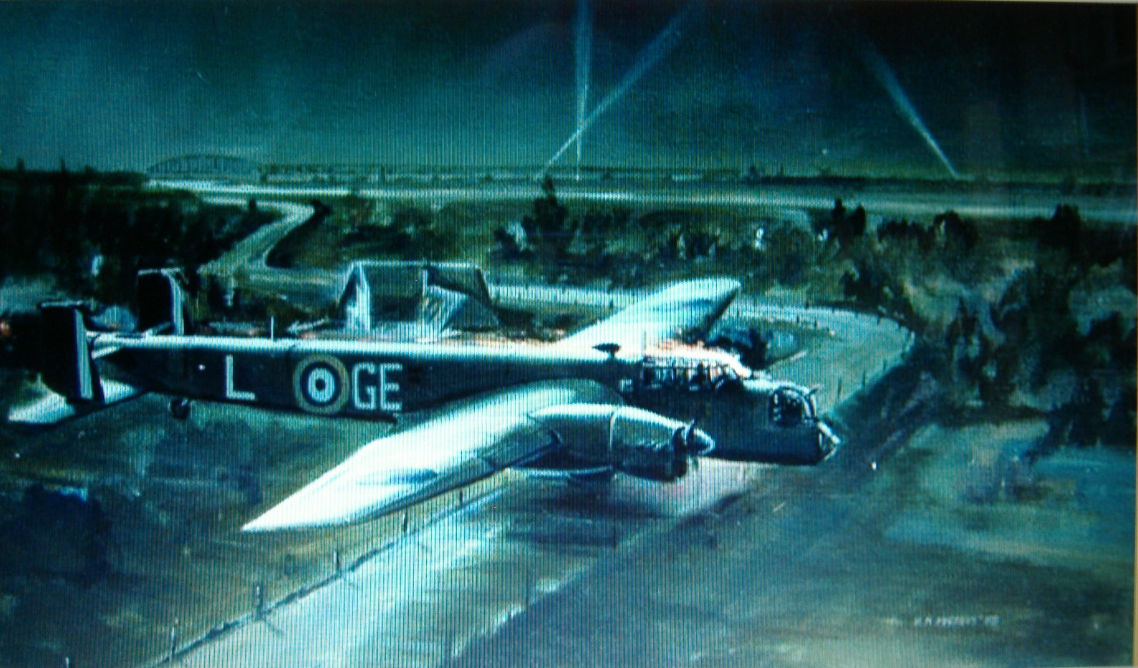
Airborne 2140 17th June 1940 from Linton on Ouse. Crashed due to engine failure, at midnight, on land identified at the Schalkwijkse Heul, alongside the Beusichemsedijk on S bank of the river Lek at Beusichem (Gederland). Pilot GJ Ford and Observer E Jones-Roberts killed three other crew taken POW. .
Their plane was a Whitley Armstrong Whitworth of the 58th Squadron, armed with a machine gun in the nose and four in the tail turret, until then the strongest defensive rear. That night they were having mechanical problems, the bomb release mechanism had stuck and a few bombs remained in the bomb bay. Sergeant Jones-Roberts had been wounded. He had been hit on the nose by one of the guns, and despite the assistance of the second pilot had lost consciousness, so they were without a navigator. The pilot tried to fly back but lost his direction and passed over Soesterberg. The Whitley was hit by flak on the left engine, which caught fire, so the pilot gave orders to bail out. The tail gunner and second pilot were able to bail out, while the aircraft was a blaze of fire. The pilot saw the aircraft was heading towards a row of houses, so he turned the plane away to starboard to avoid them – avoiding a farm house where sixty Dutch troops were quartered. The plane crossed the dyke and travelled 100 m into the flood plane. The front of the plane was crushed, and the tail broke off, the pilot and navigator were killed. Despite the fire there were still unexploded bomb on board, which were detonated a few days later. The rest of the crew were taken prisoner. After the war the bodies of the pilot and navigator were excavated, and buried. Sergeant Jones-Roberts mother and sisters Dilys and Olwen inscribed on his grave “A mavimus, animus, amabimus” “we loved him, we still love him and we will always keep him.”

