28. Douglas Williams.
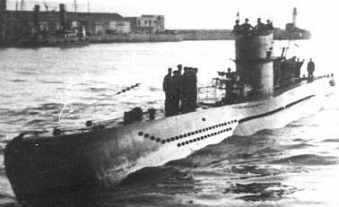
Douglas Williams was born in Llangollen June quarter 1924, son of William Samuel Williams and Kate Williams (nee Hughes) of 8 Coedafon.. Before he joined up he worked for Horspool’s of Castle Street. He was a stoker, LT/KX 137058, in the Royal Naval Patrol Service. He served on board Trawler Stella Capella. At 02.11 hours on 19th March 1942, HMS Stella Capella (FY 107), while serving in the 41st A/S Group based in Iceland, was hit by a torpedo from U-701 and sank in 2 minutes 30 seconds south of Iceland. The commander, three officers and 29 ratings were lost. Douglas Williams is commemorated Panel 10, Column 2., Memorial: Lowestoft Naval Memorial.

U-701
Name: Williams, Douglas, Rank: Stoker, Service No: LT/KX 137058
Regiment/Service: Royal Naval Patrol Service, Unit Text: H.M. Trawler Stella Capella.
Age: 18, Date Of Death: 19/03/1942
Additional Information: Son of William Samuel And Kate Williams, of Llangollen, Denbighshire.
Grave/Memorial Reference: Panel 10, Column 2., Memorial: Lowestoft Naval Memorial
At 02.11 hours on 19 Mar, 1942, HMS Stella Capella (FY 107) (Lt W.L. Sadgrove, RANVR), while serving in the 41st A/S Group based in Iceland, was hit by a torpedo from U-701 and sank in 2 minutes 30 seconds south of Iceland. The commander, three officers and 29 ratings were lost.
13th June 1917, William Williams,1, Brookside, Llangollen m Kate Hughes at St. Collen, june 1917. B June 1924, Corwen, Hughes
William’s Father given as John Hughes deceased
22nd May 1942
Presumed Killed on War Service. – Mr Douglas Williams (18), a stoker in the Royal Naval Patrol Service and son of the late Mr and Mrs Samuel Williams, 8 Coedafon, Llangollen. He was first reported missing and later presumed killed on active service. The news was conveyed to his sister, Miss Mona Williams. In civilian life Douglas was in the employ of Mr R.A. Horspool, Castle Street. He was well known and popular in the town.

