29. Charles Loftus Wilson.
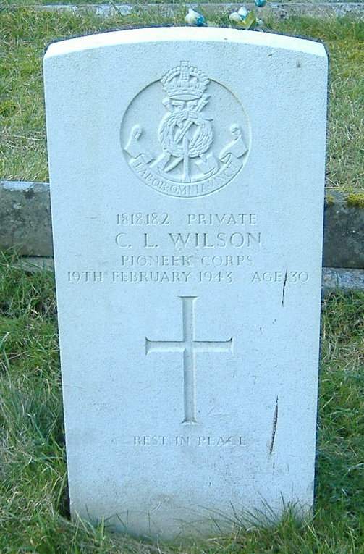
Charles Loftus Wilson was born in Overton, in June quarter 1912, son of Joshua Wilson and Margaret Wilson, (nee Humphreys?). Charles was employed by Horspools for about 15 years, before becoming a market gardener in Mold for Miss Davies-Cooke, Bryn Alyn Hall, from where he joined the Army. In June quarter 1936 Charles L Wilson married Lily Jones in Weston. Charles became a private, 1818182, in the Pioneer Corp. He death on February 19th 1943, at Cheltenham War Emergency Hospital, and was buried on 25th February in sec X grave 82 in Fron Cemetery.
Name: Wilson, Charles Loftus, Rank: Private, Service No: 1818182
Regiment/Service: Pioneer Corps
Age: 30, Date Of Death: 19/02/1943
Additional Information: Son Of Joshua And Margarete Wilson; Husband Of Lily Wilson, Of Llangollen.
Grave/Memorial Reference: Sec. X. Grave 82., Cemetery: Llangollen (Fron) Cemetery

1911 Goedsloedd Uchaf, Ruabon
Joshua Ross Wilson Vis S 42(1869) General Labourer Shropshire Dudleston

WILSON Charles L Overton June 1912, Humphreys, Ellesmere
June 1936, Charles L Wilson married Lily Jones, Weston

12th March 1943
OBITUARY
PTE. CHARLES L. WILSON.
The death occurred on February 19, at Cheltenham War Emergency Hospital, of Pte. Charles Loftus Wilson, beloved husband of Mrs, Lily Watson, and son of Mr and Mrs Wilson, Brook Street, Llangollen. The funeral which was of a semi-military nature took place on Feb 25. A short service was held at St. Collen’s Parish Church, conducted by Canon W. Alcuin Jones, M.A. (vicar). The interment took place at the Vron Cemetery, Llangollen, Canon W.A. Jones again officiating. The bearers were six soldiers, accompanied a Sergt.-Major.
The late Mr Wilson, who was 30 years of age, had been in the employ of Mr R.A. Horspool for about 15 years, from when he went to Mold as a market gardener for Miss Davies-Cooke, Bryn Alyn Hall. From there he joined the Army. The deepest of sympathy is extended to the family generally in their bereavement.
The principal mourners were: Mrs Lily Wilson (widow); Mrs. Margaret Wilson (mother); Mrs Linda Williams (sister); Bdr. A.D. Prandle (brother); Mrs Emma Lyons (sister-in-law); Mr and Mrs F. Wilson (aunt and uncle); Mr and Mrs R. Humphreys (uncle and aunt); Misses Wilson, Mrs Pridden and Miss G. Humphreys (cousins); Pts. F. Shaw and Pte. C. Connell (pals); Mr and Mrs Jones, Mr C. Horspool (friends).
Floral tributes :- ‘To you, dear, with everlasting love and remembrance,’ Lil; ‘To our dear Charlie,’ from Mamma, Dad, Linda and Bert; ‘To my dear brother and uncle,’ from Doll and little niece Gaynor; ‘With deepest sympathy: he will be sadly missed,’ All Officers and Camp Staff; ‘In loving memory,’ from his Room Mates; From Mr R.A. Horspool and Family and Employees at the nurseries, Llangollen; Uncle Bob and Auntie Annie, Bradley; Florrie, Gladys, Tommy and Ernest; all at 1, Ceiriog Villa, Chirk; Uncle Fred and Aunt Nell; All at Walton House; All at 6 and 13, Coed Afon; Doig; Mr and Mrs Wickman and Family; from Mr and Mrs R. Jones, Mold.

