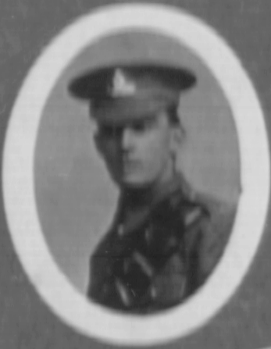
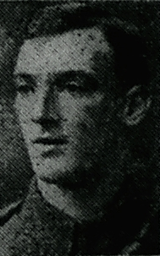
11. Arthur Wynne Edwards

Arthur Wynne Edwards was born in Llangollen DQ 1892, the son of John R Edwards and Mary Elizabeth (nee Williams) (m St Collen August 13th 1892). John R Edwards became the landlord of the Star Inn in Queen Street, and following his death Mary took over. In 1911 Arthur was working as a wood dyer, he was also a keen athlete, but by 1915 followed his brother John William into butchery. He joined Royal Garrison Artillery as a gunner 98029 31st May 1915, he was sent to Salonika 16th December 1916 and on 28th August 1917 was posted with the 295 Sege battery to Palestine, where he died of pneumonia 6th November. He is commemorated on the Jerusalem Memorial No. 18. His mother, by then at Meadow Cottage, Llangollen, later moved to Oswestry.
B 1892, butcher, star inn RGA Gunner 98029, Mother Mary Elizabeth Edwards, Star Inn joined 31st May 1915, 18th Dec 1916 to Salonika to 28th August 1917. 6/11/1918 Buried W 18 Jerusalem memorial 205 siege battery. Mother Meadow Cottage, Llangollen, subsequently moved to Picton Villas, Poole Rd., Oswestry
1901 Star Inn Queen Street
John R Edwards Head M 34(1867) Publican Llangollen Denbighshire Wales
Mary E Edwards Wife M 38(1863) Llangollen Denbighshire Wales
Sarah M Edwards Dau S 12(1889) Llangollen Denbighshire Wales
Arthur W Edwards Son S 8(1893) Llangollen Denbighshire Wales
John W Edwards Son S 5(1896) Llangollen Denbighshire Wales
John W Williams S-i-L S 25 abt 1876 Tailor Llangollen Denbighshire Wales
Edward Roberts Serv S 22 abt 1879 Liverpool Lancashire England
James Brood Visit M 24 abt 1877 Barber add London

1911 Star Inn Queen Street
Mary Elizabeth EDWARDS, Head Widow F 49 1862 Publican Business Denbigh Llangollen
Arthur Wgn EDWARDS, Son Single M 18 1893 Wool Dryer Denbigh Llangollen
John William EDWARDS, Son M 15 1896 Butcher Apprentice Denbigh Llangollen
6th December 1918
Llangollen Soldier’s Death.
GUNNER ARTHUR WYNN EDWARDS
Official News has been received of the death from pneumonia of Gunner Arthur Wynn Edwards, Royal Garrison Artillery, eldest son of the late Mr. J. R. Edwards, Star Inn, Llangollen, and Mrs Edwards, 62, Pool Road, Oswestry. He had taken part in some of the most severe fighting both on the Salonica and Egyptian front in the last2 ½ years, coming out unhurt. He was a very keen athlete, and only recently took two prizes in his battery sports in Palestine.

