11. Flight Sergeant Wynne Roberts, Royal Air Force Volunteer Reserve

Wynn Roberts was born in Vroncysyllte in the December quarter of 1919, son of Richard Roberts and Jane Roberts (nee Williams), he had two brothers and four sisters. He later went on to Bangor University, from where he volunteered and joined Royal Air Force Volunteer Reserve, as Service Number 918118, subsequently as a Flight Sergeant with 226 Squadron.
In the summer of 1941 the squadron was based at Wattisham in Suffolk, and was equipped with Bristol Blenheim IV’s. This was a light bomber, with a 3 man crew, and was used principally in daylight ant-shipping operations, and what were called ‘Circuses’ against fringe targets in North-West Europe. On 10th August a Blenheim IV Z7280, with crew of Sgt. J. Osborne RCAF, Sgt. K. McManus RCAF and Sgt. W. Roberts was shot down in the channel by a ME 109. All the crew were listed as ‘Killed in Action.’ Flight Sergeant Wynne Roberts is commemorated on panel 51, Runnymede RAF Memorial, and also on the Fron Monument.
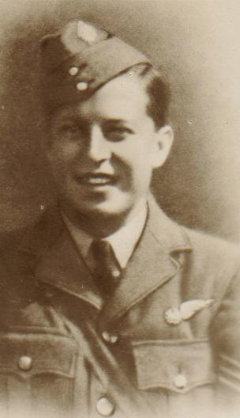
Name: ROBERTS, WYNNE, Rank: Sergeant, Service No: 918118
Regiment/Service: Royal Air Force Volunteer Reserve, Unit Text: 226 Sqdn.
Date of Death: 10/08/1941, Age: 21

Additional information: Son of Richard and Jane Roberts, of Vron, Denbighshire.
Grave/Memorial Reference: Panel 51., Memorial: Runnymede Memorial

After moving to Wattisham, Suffolk, in May 1941, the squadron converted to Bristol Blenheim IV’s and subsequently made an excellent name for itself during daylight anti-shipping operations and Circuses against fringe targets in North-West Europe.

Blenheim IV Z7280 was shot down in the channel by Me 109’s while attacking shipping. The crew were:- Sgt. J. Osborne RCAF, Sgt. K. McManus RCAF and Sgt. W. Roberts, KIA.
Wynne Roberts, birth DQ 1919 Corwen, mother Williams

